Introduction to AMDP in Business add in: Revolutionizing ABAP Development
As businesses move towards SAP HANA, leveraging its in-memory computing capabilities becomes essential for developing efficient and high-performing applications. One of the critical tools in this journey is the ABAP Managed Database Procedures (AMDP). When combined with Business Add-Ins , AMDP provides a powerful way to customize and enhance SAP applications, especially when performance is a concern. In this blog, we'll dive into what AMDP is, how it can be used within Business Add-Ins, and the benefits it brings to the table.
What is a Business Add-Ins?
Business Add-Ins (Business Add-Ins) are SAP's standard mechanism for extending the functionality of SAP applications without modifying the original code. Business Add-Ins provide predefined hooks or enhancement spots where custom code can be inserted. This makes Business Add-Ins a powerful tool for customizations in SAP.
Combining AMDP with Business Add-Ins: Why and When?
When implementing Business Add-Ins, the custom logic traditionally runs on the ABAP application server, which might not fully exploit the capabilities of SAP HANA. However, by integrating AMDPs within a Business Add-Ins, you can move resource-intensive operations to the database level. This is particularly useful for scenarios where the custom logic involves complex data retrieval, aggregation, or transformation, as these operations are executed much faster on the HANA database.
Benefits of Using AMDP in Business Add-Ins
- Performance: By offloading data-intensive operations to the HANA database, you can significantly reduce the time taken to execute these operations, especially on large datasets.
- Efficiency: AMDP enables you to write optimized database-specific logic , which is more efficient than executing equivalent logic on the application server.
- Scalability: As your data volume grows, AMDP-based solutions can scale more effectively because they leverage the power of in-memory processing directly on the database.
- Maintenance: AMDPs can reduce the complexity of ABAP code by delegating heavy data processing tasks to the database level, making the ABAP codebase cleaner and easier to maintain.
Best Practices
- Use Read-Only AMDPs: Ensure that your AMDP methods are marked as read-only unless you specifically need to update the database. This reduces the risk of unintended side effects and enhances performance.
- Error Handling: Implement robust error handling in your AMDP methods to handle any database-related issues gracefully.
- Testing: Thoroughly test your AMDP logic with different data volumes to ensure that it performs as expected under various scenarios.
There are some rules if a Business Add-Ins is marked as AMDP
- It doesn't support any filter values.
- It’s mandatory to assign a fallback class
- All AMDP Business Add-Ins method must implemented AMDP procedure with same database system
- AMDP enabled BADI can be instantiated and called like general Business Add-Ins GET BADI and CALL BADI
Now we will see the practical things how to use BADI in AMDP
1.Create a enhancement spot in se18 T-code :
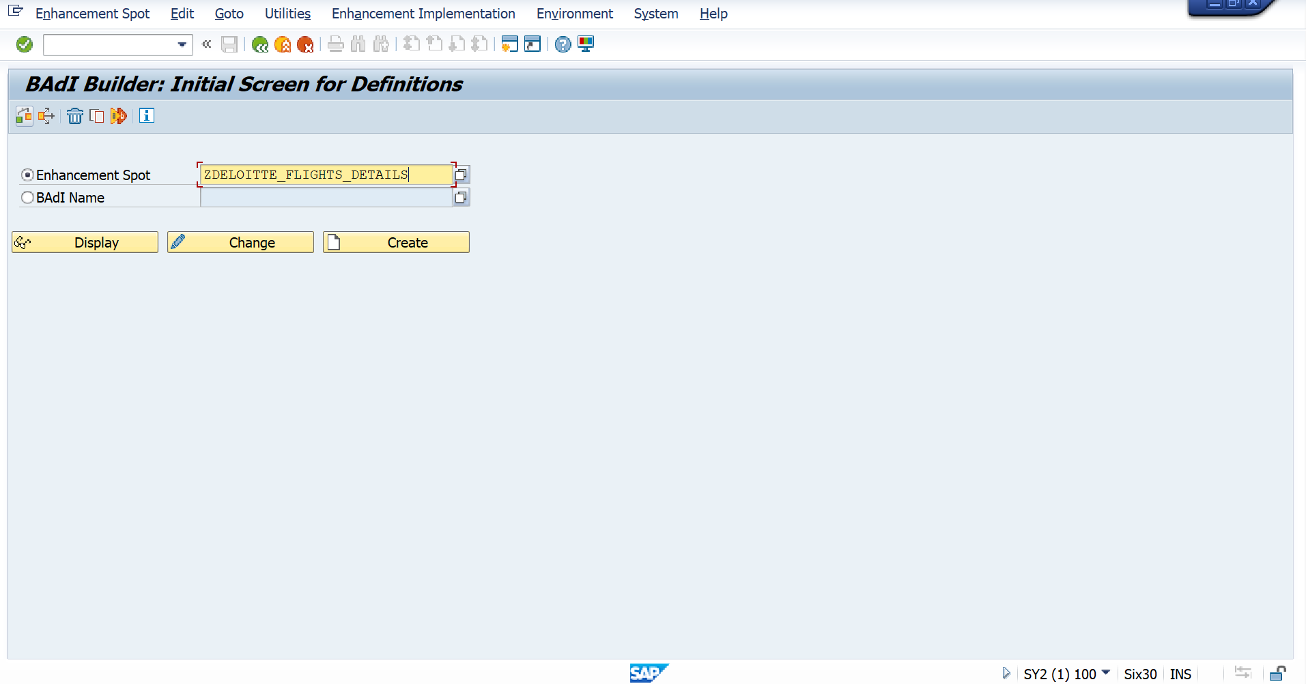
2.Create BADI Definition for the Enhance spot.
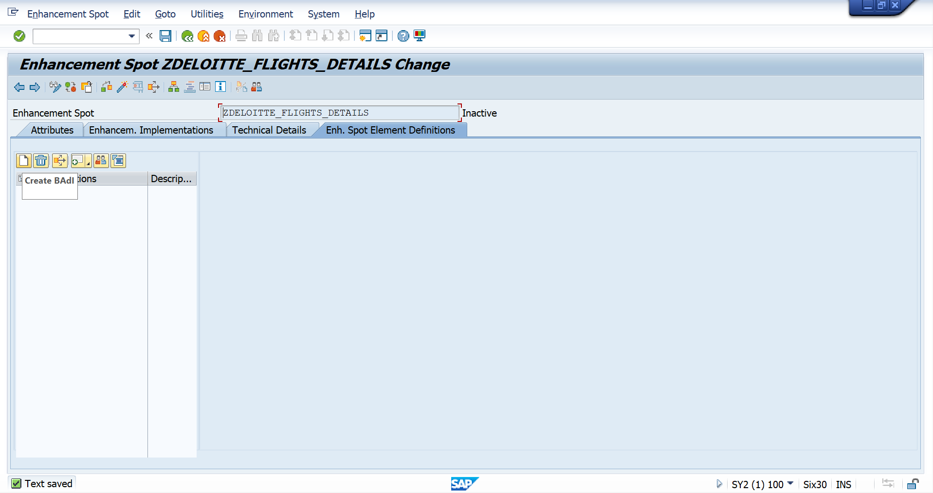
3.Once you created Business Add-Ins definition click on the AMDP Business Add-Ins checkbox
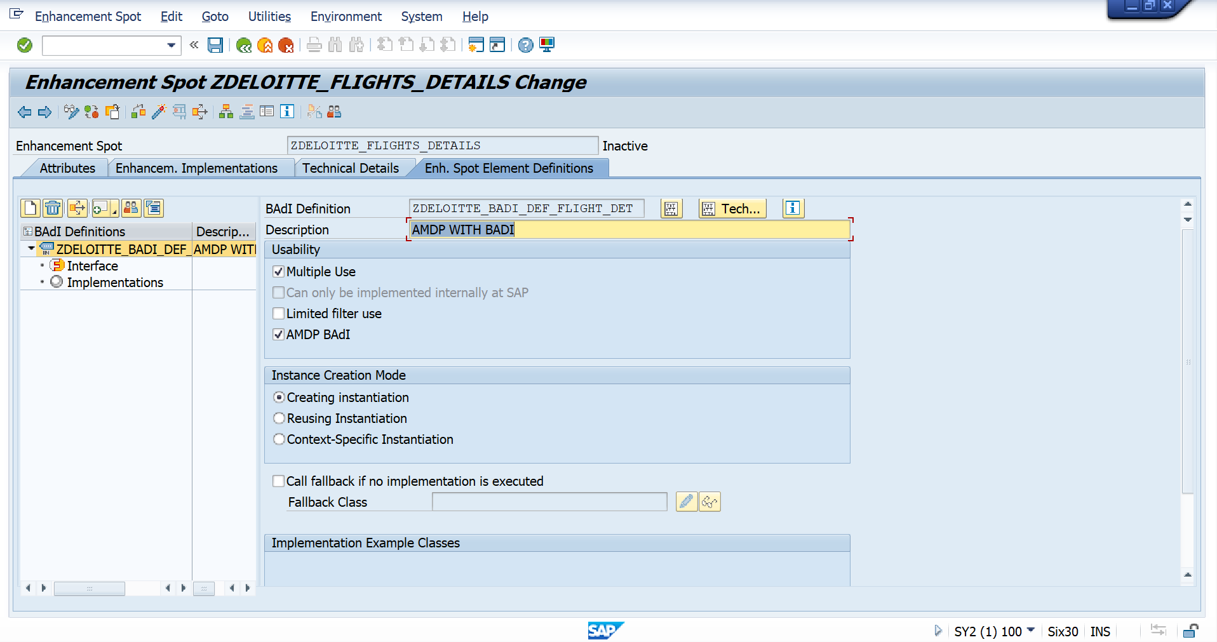

4.Create Interface for that BADI
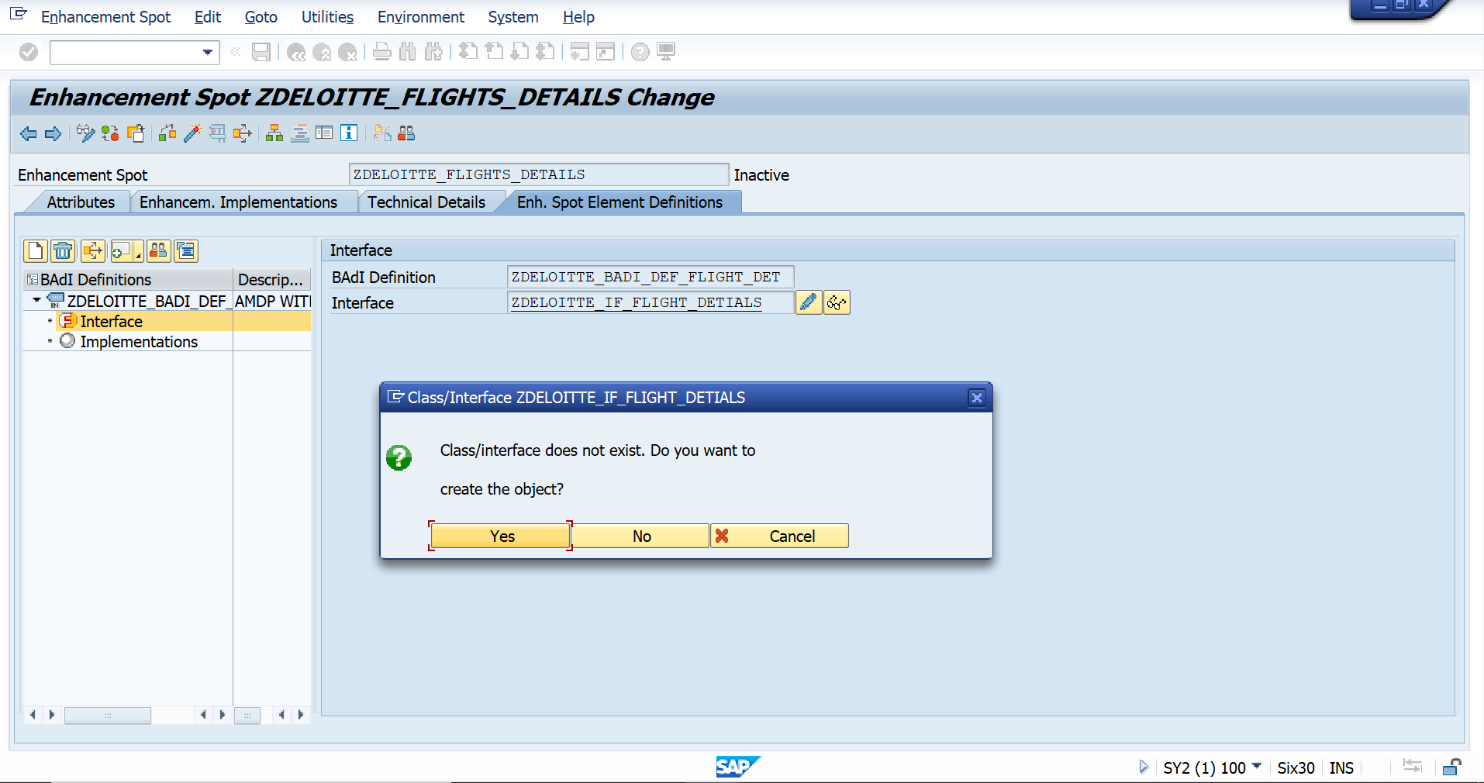
5.Once you created interface go to source code-Based
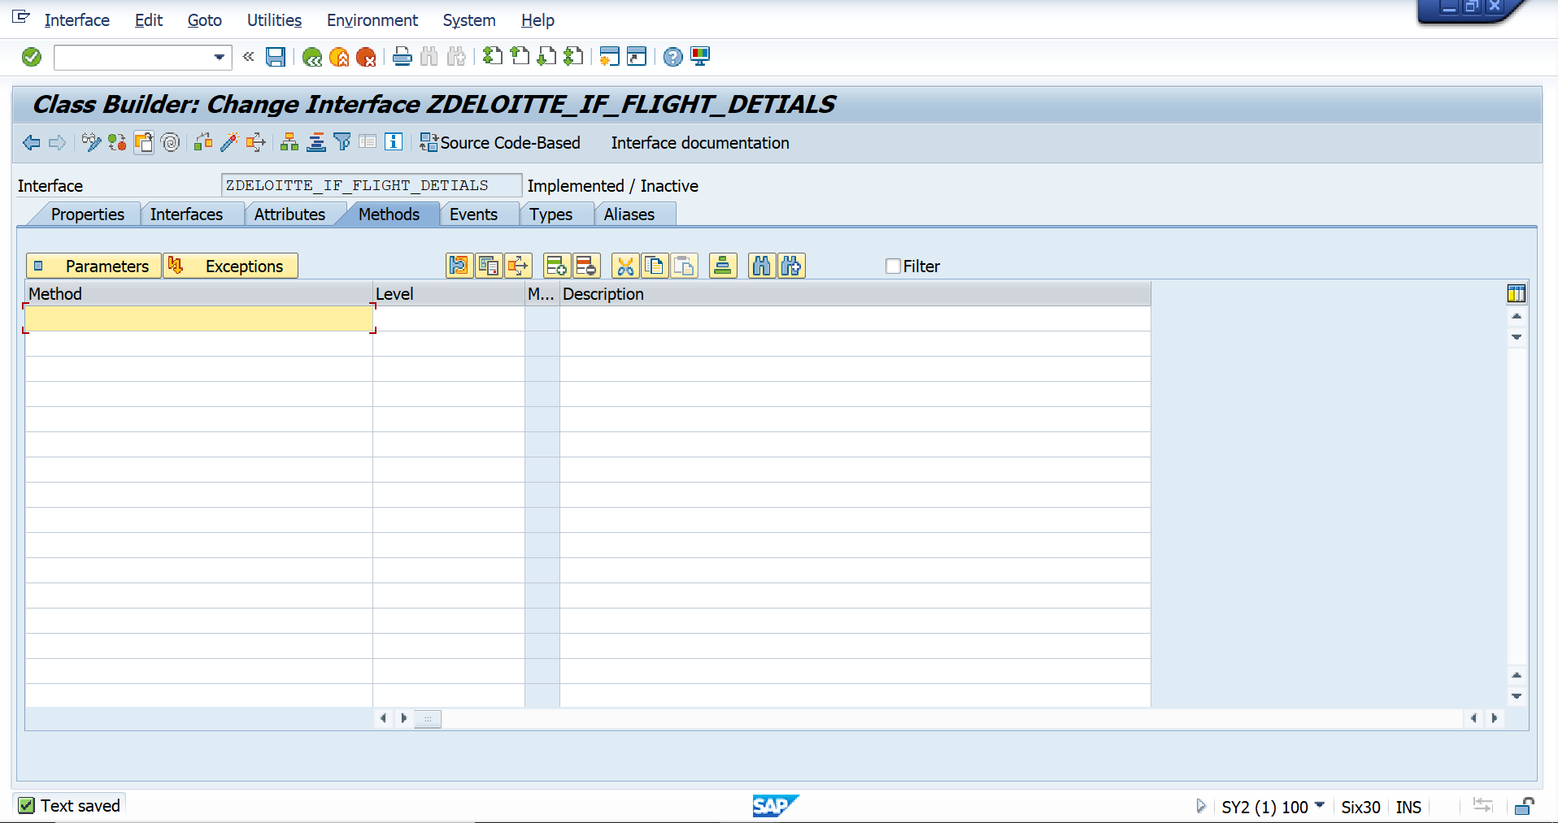
6.There provide ID_AMDP_MARKER_HDB interfaces and declare the method and activate it.
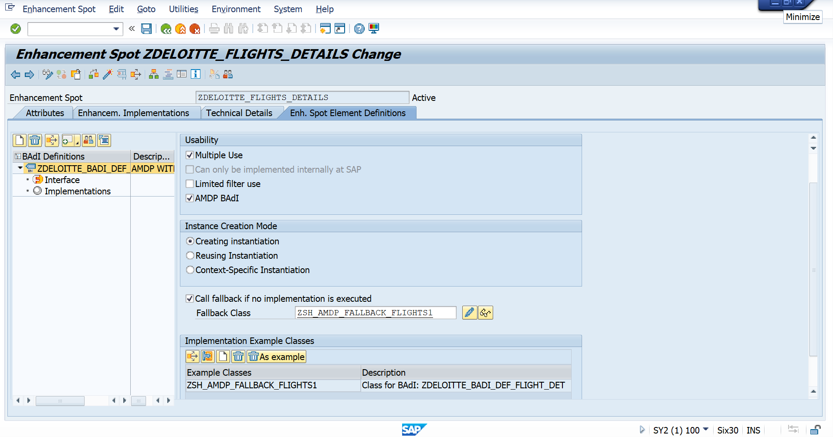
8.Copy the fallback class name now go to eclipse by providing alt+f8 we can find the fallback class in eclipse .
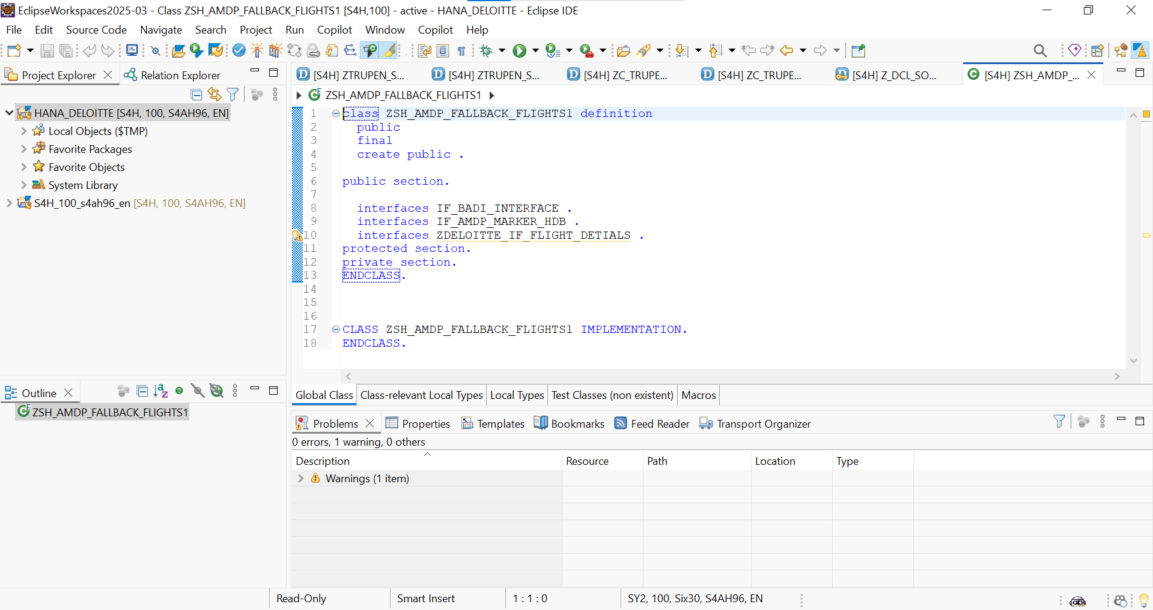
9.Provide the implementation to the fallback class
class ZSH_AMDP_FALLBACK_FLIGHTS1 definition
public
final
create public .

public section.

interfaces IF_BADI_INTERFACE .
interfaces IF_AMDP_MARKER_HDB .
interfaces ZDELOITTE_IF_FLIGHT_DETIALS .
protected section.
private section.
ENDCLASS.

CLASS ZSH_AMDP_FALLBACK_FLIGHTS1 IMPLEMENTATION.
METHOD ZDELOITTE_IF_FLIGHT_DETIALS~fetch_data by DATABASE PROCEDURE FOR HDB LANGUAGE SQLSCRIPT OPTIONS READ-ONLY USING sflight.
et_flight = SELECT * FROM sflight WHERE carrid = iv_carrid;
ENDMETHOD.

ENDCLASS.

10.Now we can activate the Business Add-Ins.
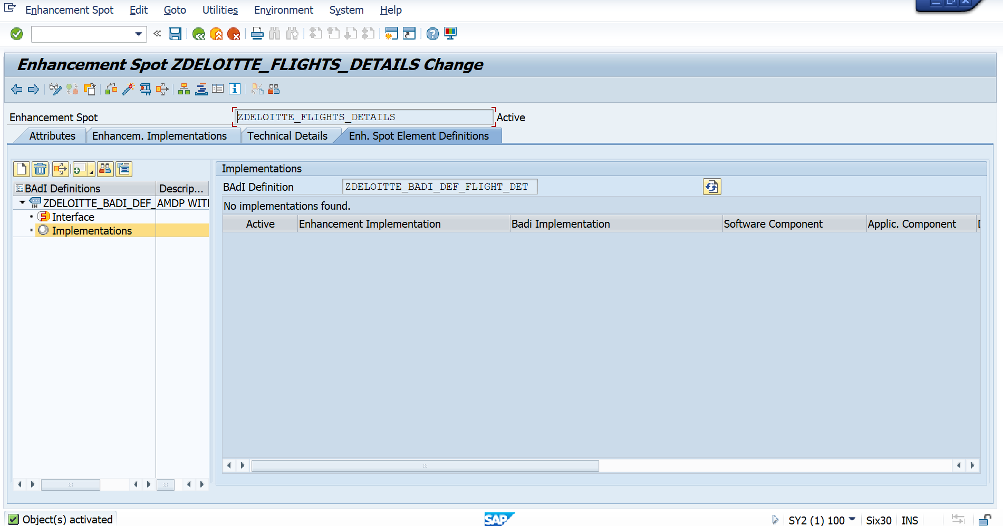

11.To call the Business Add-Ins we have to create one more ABAP class in SE24.
Open that class in the eclipse and write the below code.
class ZSH_CL_AMDP_BADI7 definition
public
final
create public .

public section.
INTERFACES : if_amdp_marker_hdb.

METHODS : execute IMPORTING VALUE(iv_carrid) TYPE sflight-carrid

EXPORTING VALUE(et_flight) TYPE flighttab.

protected section.
private section.
ENDCLASS.

CLASS ZSH_CL_AMDP_BADI7 IMPLEMENTATION.
METHOD execute BY DATABASE PROCEDURE FOR HDB LANGUAGE SQLSCRIPT OPTIONS READ-ONLY USING ZDELOITTE_BADI_DEF_FLIGHT_DET=>FETCH_DATA.

CALL "ZDELOITTE_BADI_DEF_FLIGHT_DET=>FETCH_DATA"(iv_carrid => :iv_carrid , et_flight => :et_flight);

ENDMETHOD.

ENDCLASS.
Create a zreport program in the se38.
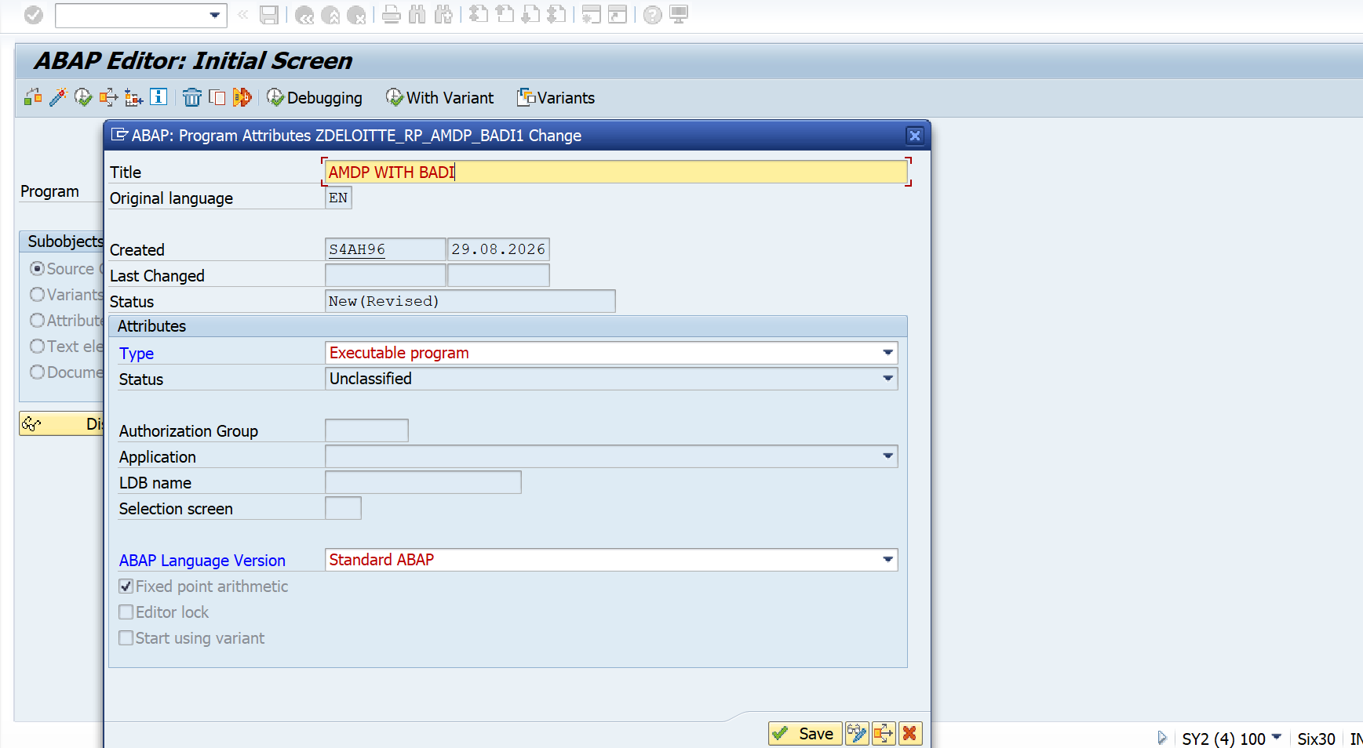

Code :

*&---------------------------------------------------------------------*
*& Report ZDELOITTE_RP_AMDP_BADI1
*&---------------------------------------------------------------------*
*&
*&---------------------------------------------------------------------*
REPORT ZDELOITTE_RP_AMDP_BADI1.
DATA(lo_obj) = new ZSH_CL_AMDP_BADI7( ).
lo_obj->execute(
EXPORTING
iv_carrid = 'AA'
IMPORTING
et_flight = DATA(lt_flight)
).
cl_demo_output=>display( lt_flight ).

Ouput:
